Transport from the airport

Korea’s international airports are located very far from city centers, but transport to and from them is very convenient. Every airport has limousine buses and taxis. Taxis would be a great choice for door-to-door travel, but normally the fare to the city center is quite expensive and if you face traffic congestion, it can be slow. For that reason, many visitors who have been to Seoul highly recommend using airport limousine buses and subways. Airport line from Incheon and Gimpo is connected to Seoul Metro subway lines.

AIRPORT | INFORMATION | DISTANCE TO CITY CENTER | TAXI FARE TO CITY CENTER | LIMOUSINE  BUS | PUBLIC TRANSPORT TO CITY CENTER
INCHEON | 82-2-1577-2600  http://www.airport.kr/eng/ | About  58km | 70,000 ~  120,000 won | Deluxe  12,000~13,000 won  Standard  7,500~8,000 won | Rail & subway  1hour 10min  Limousine bus  1hour 10-20min
GIMPO | 82-2-2660-2114  http://www.airport.co.kr/doc/gimpo_eng/index.jsp | About  15km | 12,000 ~  24,000 won |  | Rail & subway  45min

The easiest way to your accommodation - using the airport limousine bus

Buses from Incheon International Airport to Seoul or Gimpo Airport operate at 10-15 minute intervals during normal flight operation hours. Deluxe Limousine Bus tickets to Seoul cost 12,000 ~13,000 won, Standard Limousine Bus tickets cost 7,500~8,000 won. Tickets can be purchased at the Transportation Information Counter near the Exits No. 2, 4, 9, 13 on the Arrival Floor (1st floor) in Incheon International Airport or at the bus stops themselves. Passengers need to confirm the bus number and location because there are many bus routes to and from the airport. You can pay cash to the bus driver.

If you plan to stay at Hotel Seokyo or Casaville Shinchon , use No.6002 bus. Take Airport bus No. 6011 in order to come to Ewha Womans University from Incheon International Airport.
*Route information

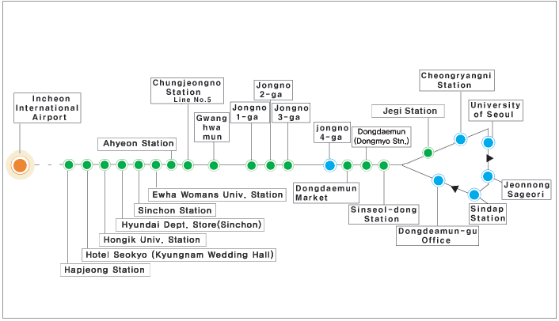
Airport Railroad (Access to the Seoul Metro)
To access the Seoul Subway system from Incheon International Airport, use the AREX airport rail service (B1 level of Transportation Center). There are two types of service: Express trains (direct from Incheon Airport to Seoul Station; 43 min, 13,300 KRW), and commuter trains (stops at nine stations between Incheon Airport and Seoul Station; 53 min, fare varies). Among the nine stations along the commuter service, five stops (Gyeyang, Gimpo Airport, Digital Media City, Hongik Univ., and Seoul Station) offer subway transfers, adding to the convenience of passengers seeking transfer to the Seoul or Incheon subway lines.

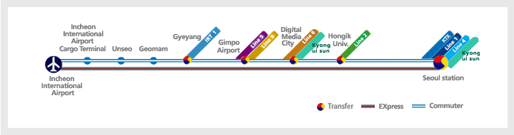

* Taxi fare
Taxi fare is not as expensive as in other developed countries. In addition they are plentiful and safe. They can be found at taxi stands in most busy city areas. There are also special company taxis that can be requested by phone (“call taxis”), however, the fare is slightly higher than regular taxis. Deluxe taxes with yellow cabs charge higher than regular taxis. An increasing number of taxi drivers nowadays speak some English.
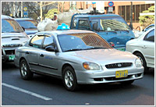
Regular Taxis
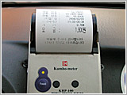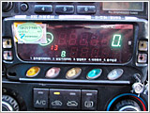

The fare system is based on both distance and time.
Fares begin at ￦3,000 for the first 2 kilometers and go up incrementally ￦100 every 144 meters beyond that. If the taxi is going less than 15 kilometers per hour, an additional charge of ￦100 per 35 seconds is added to the fare.
The fare between Incheon International Airport and downtown Seoul is usually around ￦50,000, although it can be a little higher if traffic is congested.
Fares increase 20 percent between midnight and 4 a.m.
Deluxe Taxis & Jumbo Taxis

Deluxe taxis called “mobeom” taxi in Korean, are black with a yellow sign on the top and the words “Deluxe Taxi” written on the sides. They offer more passenger space and a much higher standard of service. Fares are ￦5,000 for the first 3 kilometers and ￦200 for each additional 164 meters or each 39 seconds if the speed drops below 15 kilometers per hour. The usual fare between Incheon Int’l Airport and downtown is about ￦80,000 won (including toll). There is no late-night surcharge. Deluxe taxis can be taken at stands located at hotels, stations, bus terminals, and major city streets.

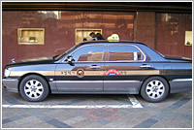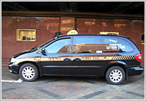
< Deluxe taxi> <Jumbo Taxi>
Jumbo Taxi means eight-passenger van taxis which are also available for larger groups. They are equipped with simultaneous foreign language interpretation by phone, receipt-issuing equipment, and a credit card processing terminal. Fares are the same as deluxe taxis. Passengers also carrying large amounts of baggage may find them convenient.

From Airport to Your Residences
1. From Incheon Int’l Airport

1) To Shinchon Casaville

(1) Airport Limousine

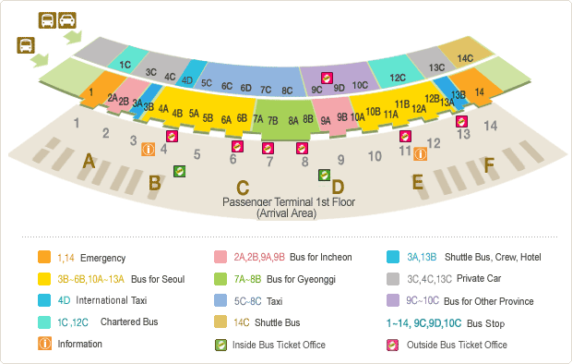

- For your convenience, we recommend you to come out through exit number 5B or 12A.
- Please buy a ticket at the ‘Ticket Office’ before you take the bus.
(* You can check the ‘Inside’ and ‘Outside’ Ticket Office in the above map.)
- Fare will be 10,000 won.
- Please take bus number 6002 and get off at “Sinchon Station”.
- Shinchon Casaville is 5 minutes away from Exit 7 on foot.

* For more information on Airport Limousine
http://www.airport.kr/airport/traffic/bus/busList.iia?flag=E&fake=1313388739435

(2) Airport Express (Subway)

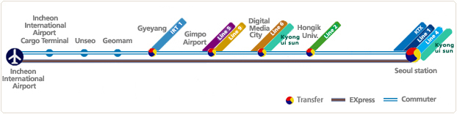
- You can take the Airport Express at the B1 floor in the Transportation Center.
- Fare will be 1,200 won.
- Please transfer to subway line No.2 (Green Line) at “Hongik Univ. (홍대입구)” station and get off at “Sinchon (신촌)” station which is the station immediately after Hongik Univ. station.
- Shinchon Casaville is 5 minutes away from Exit 7 on foot.

* For more information on Airport Express http://www.airport.kr/iiacms/pageWork.iia?_scode=C1203020000&fake=1313388734965

(3) Taxi

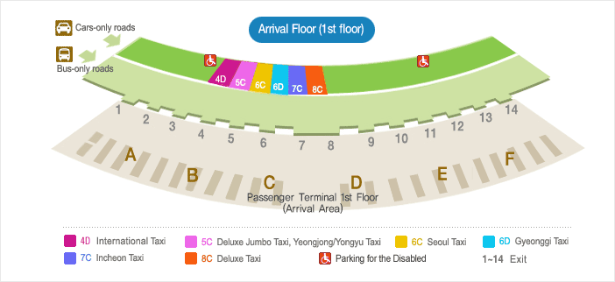

- Taxi stands are located on the arrival level (1F) at the passenger terminal between platform 4D and 8C.
- Estimated taxi fare will be around 40,000 ~ 60,000 won for regular taxi and 70,000 ~ 100,000 won for deluxe taxi. (*Deluxe taxi is black in color.)
- Toll fee (7,100 won) will be the passenger’s responsibility.
- Int’l Taxi fare is around 55,000 won (*fixed fare) including toll fee.
- If you take the van taxi, it will cost around 60,000 won to Shinchon Casaville.
(*Since Int’l Taxi is Seoul city’s official service and the drivers are fluent in foreign languages, we recommend you to take the international taxi.)

* For more information on Airport Taxis
http://www.airport.kr/iiacms/pageWork.iia?_scode=C1203030000&fake=1309862751029

* For more information on Int’l Taxi (Tel : (82) 1644-2255 (*24-hour consultation ))
http://www.intltaxi.co.kr/

* Shinchon Casaville - Address : 57-26 Nogosan-Dong, Mapo-Gu, Seoul
Tel : (+82)02-6220-4000 / Fax : (+82)02-6352-1101)
Website : http://www.casaville-shinchon.co.kr/eng/index.php

2) To Hotel Seokyo

(1) Airport Limousine

- For your convenience, we recommend you to come out through exit number 5B or 12A.
(*Please refer to the map in the 1st page.)
- Please buy a ticket at the ‘Ticket Office’ before you take the bus.
(* You can check the ‘Inside’ and ‘Outside’ Ticket Office in the map mentioned above.)
- Fare will be 10,000 won.
- Please take bus number 6002 and get off at “Hotel Seokyo” station.
- Hotel Seokyo is two minutes away from Exit 9 on foot and it is near Hongik Univ. and Industrial Bank of Korea.

(2) Airport Express (Subway)

- You can take the Airport Express at the B1 floor in the Transportation Center.
- Fare will be 1,200 won.
- Please get off at “Hongik Univ.(홍대입구)” station.
- Hotel Seokyo is two minutes away from Exit 9 on foot and it is near Hongik Univ. and Industrial Bank of Korea.

* For more information on Airport Express http://www.airport.kr/iiacms/pageWork.iia?_scode=C1203020000&fake=1313388734965

(3) Taxi

-Please refer to 2nd page.

* Hotel Seokyo - Address : 165 Yangwha-Ro, Seokyo-Dong, Mapo-Gu, Seoul, Korea
Tel : 02-330-7777 / Fax : 02-333-3388
Website : http://www.hotelseokyo.co.kr/ENG/main/main.asp

2. From Gimpo Int’l Airport

1) To Shinchon Casaville

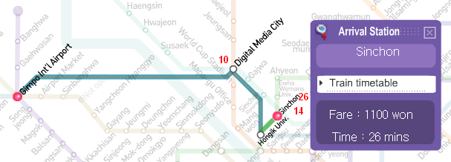
(1) Airport Express (Subway)
- You can buy a ticket at the B1 floor and take the Airport Express at the B3 floor.
Fare : 1200 won
Time : 26 mins
- Please transfer to subway line No.2 (Green Line) at “Hongik Univ. (홍대입구)” station.
- Please get off at “Sinchon (신촌)” station which the station immediately after Hongik Univ. station.
- Shinchon Casaville is five minutes away from Exit 7 on foot.

* For more information on Seoul Subway
http://www.smrt.co.kr/Eng/index.jsp#

(2) Taxi

- You can take a taxi in front of the terminal.
- Estimated taxi fare will be around 20,000 ~ 30,000 won for regular taxi and Int’l taxi.
- If you take the van taxi, fare will be around 30,000 ~ 40,000 won.
(*There is no toll fee between Gimpo Int’l airport to all destinations in Seoul city.)

(3) Airport Limousine

- Since there is no direct bus from Gimpo Int’l Airport to Sinchon Casaville, we recommend you to use “Airport Express” or “Taxi”.

2) To Hotel Seokyo

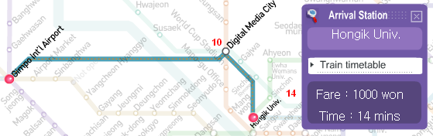
(1) Airport Express (Subway)
Fare : 1100 won
Time : 14 mins
- You can buy a ticket at the B1 floor and take the Airport Express at the B3 floor.
- Please get off at “Hongik Univ.,(홍대입구)” station.
- Hotel Seokyo is two minutes away from Exit 9 on foot and it is near Hongik Univ. and Industrial Bank of Korea.

* For more information on Gimpo Int’l Airport transportation service
http://www.airport.co.kr/doc/gimpo_eng/info/RE03010101.jsp

(2) Taxi

-Please refer to the previous page.

(3) Airport Limousine

- Since there is no direct bus from Gimpo Int’l Airport to Hotel Seokyo, we recommend you to use “Airport Express” or “Taxi”.

From Your Hotel to Ewha Womans University

1. Subway

The subway is the easiest and quickest way to get to your destination in Seoul. You can either buy a one-way ticket, or a pre-paid bus card. The basic fare begins with 1,000 won and increases according to distance. Most announcements signs are in both Korean and English. There are 9 subway lines in Seoul, which you can distinguish by different colors and numbers.

To get to Ewha, take Green line number 2 and get off at “E-dae-yeok ” (stop #241), which is short for the Ewha Womans University stop. Take Exit 2 or Exit 3 and walk downhill. A 2-3 minute walk will lead to you the main gate of the university.
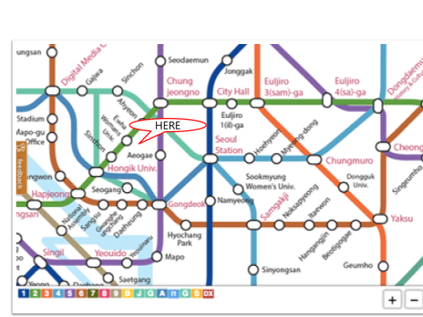

You can look up relevant information at the official website of the Seoul Metropolitan Subway Corporation at http://www.seoulsubway.co.kr. If you get lost or need information related to the subway system, you can contact 735-5678 for English help.

Transportation card
T-Money can be used for public transportation on all subways that link Seoul and on every bus (both intra-city and village) that serve routes in Seoul or local districts in Gyeonggi Province and Incheon. You can buy T-Money cards at most convenience stores and bus stop kiosks.

2. Taxi

Taxis in Seoul are convenient and safe. The initial fare on the meter is 3,000 won for a regular taxi, and the black luxury taxis (called “Mo-beom”) will cost more starting at the initial fare of 5,000 won. Taxi fares increase 20% after midnight. Ask the taxi driver to take you to “E-dae (Ewha Womans University: 이화여자대학교).”

3. Bus

There are so many buses which stop near Ewha Womans University subway station and also near the back gate. You can take green buses (No. 6716, 5712, 5714, 6712) or blue buses (No. 153, 163, 171, 172) to get off at the subway station near the university. You can take green buses (No. 6714, 7737) or blue buses (No. 470, 601, 672, 710, 750A, 750B) to get off near the university back gate. There may be more options. For general information on how to get around by bus in Seoul, visit
http://www.visitseoul.net/en/article/article.do?_method=view&art_id=39545&lang=en&m=0004007002011&p=07.

Ewha Womans University Campus Map

- From Main Gate to International Education Building
(conference venue)