Information about Seoul Tours

A brief introduction of Seoul

Seoul is the capital city of the Republic of Korea, with over 600 years of history. This megalopolis is home to about 10 million people. Seoul has been a principal settlement for over 2,000 years, and it was founded in 18 B.C. when Baekje, one of the Three Kingdoms of Korea, established its capital. It also functioned as the capital of Korea during the Joseon Dynasty (1392-1910) and the Korean Empire. Seoul is special in that historical sites such as Gyeongbokgung Palace and modern cultural facilities like the skyscraper “63” Building coexist in harmony. Furthermore, its diverse range of numerous modern amenities such as museums, galleries, universities and churches, makes it one of the most attractive contemporary cities in the world. In 2010, Seoul City garnered the title of World Design Capital. The attractions are too numerous to list, but this page highlights the most important and popular places for visitors.

Recommended Destinations of Seoul

Gyeongbokgung Palace / Changdeokgung

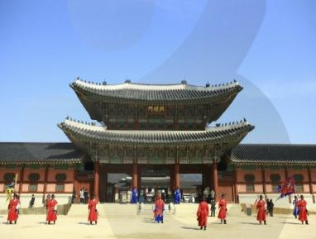
Gyeongbokgung Palace (Northern Palace, built in 1395) is one of the most beautiful and elegant palaces in Seoul. Inside, the most representative edifices of the Joseon Dynasty--Gyeonghoe-ru Pavilion and Hyangwonjeong Pond--still retain an antique and elegant atmosphere. The National Palace Museum of Korea and the National Folk Museum are also located within the palace grounds and included in the price of the ticket. World Heritage Site Changdeokgung (Eastern Palace) is also highly recommended and located five minutes away by bus or taxi.

*Directions to Gyeongbokgung: Subway line 3 (orange), Gyeongbokgung Station, Exit 5; or subway line 5 (purple), Gwanghwamun Station, Exit 2
**For more information on Gyeongbokgung: http://www.royalpalace.go.kr/html/eng/main/main.jsp, or Changdeokgung: http://eng.cdg.go.kr/main/main.htm

Namsangol Hanok Village

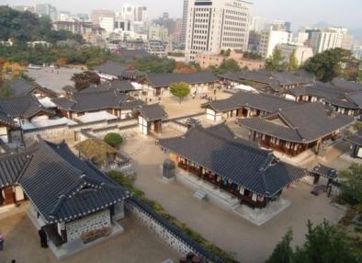
Namsangol Hanok Village is one of the most famous folk villages in Korea and located in the midst of downtown Seoul. This village has five restored traditional Korean houses which once belonged to those of various social classes, ranking from peasants to the king, and a pavilion, a pond and a time capsule. The village will help you understand the daily life of the past, and the traditional houses and their vintage accessories provide a great photo opportunity. You may also try traditional games such as 'neolttwigi' (see-saw jumping), 'tuho'(arrow throwing) and 'yunnori' (traditional game of throwing wooden yut sticks). [Closed every Tuesday.]

*Directions: Subway line 3 or 4 (orange or blue), Chungmuro Station, Exit 3 or 4 (two minute walk)
**For more information: http://hanokmaeul.seoul.go.kr/index.jsp

Insadong

Insadong was once better known as “antique alley,” famous for its small galleries, teahouses, and congregation of artists. Over the past few years, it has undergone a facelift to make it more attractive to locals and tourists alike. Many surprises await in the narrow alleys, such as modern art galleries, traditional craftwork, antique sellers, fortune tellers, cafés and teahouses of hanok design (traditional Korean architecture). Consider stopping in one of the many traditional teahouses to sample varieties of tea such as ginseng, green plum, and chrysanthemum. Traditional performances and exhibits are also frequently held on the main thoroughfare. This is an ideal place to peruse and buy souvenirs for your family and friends, if not that “special find” for yourself.

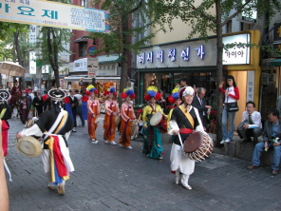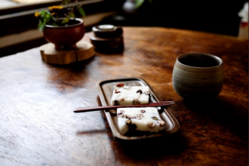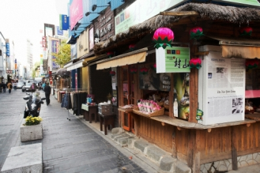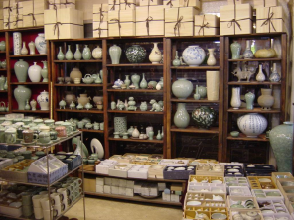

* Directions: Subway line 3 (orange line), Anguk Station, Exit 6 (one-minute walk)
**For more information: http://www.insainfo.or.kr/

Samcheongdong / Bukchon Village
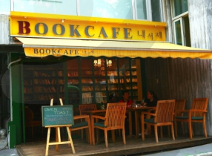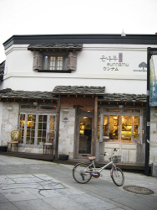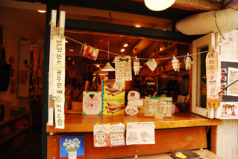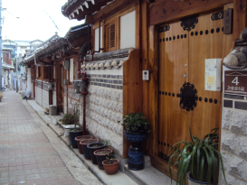

Not far from Gyeongbukgung Palace and Insadong, the neighborhood of Samcheongdong has emerged as a more contemporary version of Insadong. Lined with galleries, restaurants, coffee shops, chic boutiques and wine lounges, Samcheongdong infuses both traditional and modern elements as well as touches of European charm. For those with extra time during your visit, consider combining a stroll through Samcheongdong after visiting the traditional residential area of Bukchon Village. For more information: http://bukchon.seoul.go.kr/eng/index.jsp.

The National Museum of Korea / The War Memorial of Korea

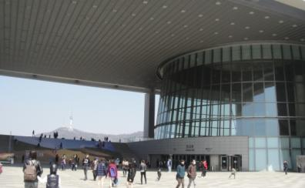
The National Museum of Korea is the largest museum in Korea and houses precious Korean cultural assets that tell the story of Korea’s long history, from ancient days to the modern era. The museum is adjacent to Yongsan Family Park, a wooded grassland that serves as a natural habitat for various fauna and flora, with also has a number of traditional and modern sculptures.

The War Memorial of Korea is also located nearby just two subway stops away. It provides detailed accounts of wartime history and displays a daunting array of collections and wartime relics. Outdoor sculptures are also very memorable. [Both museums have free general admission but are closed on Mondays.]

* Directions to National Museum of Korea: Subway line 4 (blue), Ichon Station, Exit 2 (5-minute walk)
** For more information: http://www.museum.go.kr/main/index/index002.jsp
* Directions to War Memorial of Korea: Subway line 4 (blue) or 6 (brown), Samgakji Station, Exit 12 (5-minute walk) ** For more information: https://www.warmemo.or.kr/eng/intro/message/message.jsp

N Seoul Tower

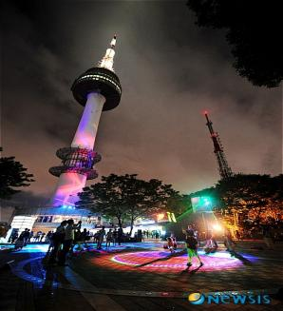
N Seoul Tower is considered to be the best observatory space of Seoul, where you can appreciate the spectacular scenery of much of the city. Originally, it was constructed as Korea’s first total electric wave tower to send TV and radio broadcasts in the Seoul metropolitan area in 1969. Half of the entire population of Korea watch and listen to the broadcasts through the electric wave tower of N Seoul Tower. The Tower opened to the public in 1980, becoming a sightseeing destination for both Korean and foreigners. You can reach the Tower by cable car, shuttle bus from the mountain base, or an easy hike (try starting from the front of the Grand Hyatt Hotel). Daytime views are impressive, but you may also enjoy the vibrant city nightscape while sipping a glass of wine in the Tower’s revolving restaurant.

*For more information: http://www.nseoultower.co.kr

Itaewon Shopping and Restaurants

For those interested in name-brand shopping, tailored suits, and antique reproductions, Itaewon has long had a reputation for catering to tourists. Many bargains may be found here, especially name brands officially manufactured in Korea and exported abroad (but do beware of counterfeit goods). Itaewon is increasingly becoming popular for its quality international cuisine, due in part to the rising immigrant population but also to its budding reputation for attracting highly-trained chefs from around the world. Greek, Indian, French, Bulgarian, and Middle Eastern menus are only a few of the many different types represented in Itaewon. Food enthusiasts may be especially thrilled with the prospects of restaurants and bars located in the main alley behind Hamilton Hotel (Subway line 6 (brown), Itaewon Station, between Exits 1 and 2). Nightlife also has plenty to offer in terms of sports bars, dance clubs, and cocktail lounges to the mixed crowd of locals, expats, U.S. soldiers, and tourists.

LeeUm, Samsung Museum of Art

At the eastern end of Itaewon Street lies one of Seoul’s architectural treasures. The LeeUm Museum is an impressive structure of three unique buildings, holding historical and modern art collections. Enjoy the stunning sculptures outdoors and experience the spiral staircase inside.

*Directions: Subway line 6 (brown), Hangangjin Station, Exit 1 (turn right up the first street past the school and walk five minutes up the hill)
** For more information: http://leeum.samsungfoundation.org/eng/main.asp

Performances
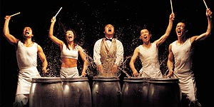
Seoul has several long-running shows especially popular with foreign visitors. NANTA is a non-verbal cooking extravaganza and has performed globally with much acclaim. For information and booking: http://nanta.i-pmc.co.kr/en/index.asp. JUMP! is a comical martial arts performance, and BREAKOUT is a comedy about a prison break incorporating Korea’s “B-boy” techniques of dance, martial arts, and circus performance. For information and booking of the latter two: http://www.yegam.com/yegam/eng/. Shows are conveniently located downtown.

▪ Korea Tourism Organization official website – http://english.visitkorea.or.kr/enu

If you are interested in organized tours (Half Day, Full Day, Night Tour, Themed Tour), please use the websites listed below. You may make a reservation online.

- http://www.jimsclub.net/
- http://www.cosmojin.com/
- http://en.nicetours.co.kr/
- http://seoultour.ahndesign.kr/
- http://seoulmate.byus.net/home/first.php
- http://iloveseoultour.com/eng/

You can also organize your own itinerary by referring to the internet sites below:

- http://www.visitseoul.net/main.jsp : This website gives useful information about Seoul: history, customs, symbols, weather, transportation, etc. It also shows tour plans suited to your interests and provides free downloadable guidebooks.
- http://en.seoulcitybus.com/ : It is highly recommended that you use the Seoul City Tour Bus if you would like personally customize your journey. The bus circulates around 27 stops for tourists to get on and off. Most stops include famous tourist attractions and hotels. All the routes and location information are shown on the website.

*********************************************************************************************************
Themed tour: The Korean Demilitarized Zone (DMZ)

The Korean War reached a ceasefire in 1953 under the Korean Armistice Agreement, dividing the Korean peninsula along the 38th Parallel, now commonly known as the DMZ. Touring the DMZ will give you the chance to sense the ongoing military tension between North and South Korea over the last fifty years.
Many travel agencies provide tours to the DMZ, usually divided into three categories: Panmunjeom/JSA Tour, DMZ Tunnel Tour, and DMZ Fence Tour. Most tours begin early in the morning and return to Seoul by mid-afternoon. Tour fees normally range between 45,000 and 85,000 won (US$40-$80) depending on the type of tour. The Panmunjeom/JSA (Joint Security Area) tour is highly recommended at around US$70-80.

The USO (United Services Organization) runs popular tours to the DMZ (Panmunjeom/JSA) around twice a week for U.S. military personnel and civilians. Reservations should be made well in advance. For tour information and booking: http://www.koridoor.co.kr/. The bus departs from Camp Kim USO (Subway line 4 (blue) or 6 (brown), Samgakchi Station, Exit 10). After the DMZ tour, you might consider a quick visit to the War Memorial of Korea, located across the street from the USO.

Many other reputable travel agencies provide DMZ tours almost daily, departing conveniently from downtown Lotte Hotel (Subway line 2 (green), Euljiro-1 Station, Exit 7 or 8). Please dial (82-2) instead of (02) for phone numbers below if calling from overseas.

- International Culture Service Club: (02) 755-0073 (http://www.tourdmz.com/english/main.php)
- Wow Corea Tour: 02-739-3337 (http://www.wowcoreatour.com/)
- Good Morning Tours: 02-774-3226 (Lotte Hotel on weekdays, Donghwa Duty Free shop on weekends)
- The Korea Travel Bureau: 02-778-0150
- Panmunjom Travel Center: 02-399-2180
- The Chung Ang Express Tour: 02-2266-3350

IMPORTANT: All visitors must bring their passports and comply with the dress code. Some agencies have a restricted country list which may require a quick background check (e.g., China, Hong Kong, Taiwan, Russia, India). Please confirm your nationality and eligibility with each agency.

