Accommodation Info

1. International Guest House on Ewha Womans University campus
(Very limited vacancy, booking on a first-come, first served basis)
The greatest advantage is its location, but breakfast is not served. You can have Korean breakfast at a student cafeteria or nearby cafes. The nearest Starbucks open at 7: 30 a.m. and cafes near the university open at around 9 a.m.

Single room $60
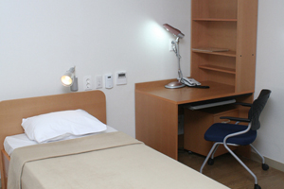

To make reservations email eritskats@gmail.com.
We have to make advance cash payment to secure guest rooms, which is not refundable. Please check with us room availability as soon as you receive notification on your abstract submission and transfer your accommodation fee with registration to complete your room reservation.

2. Casaville Shinchon Residence
※ Dollar/won exchange rate: 1 USD = 1067 won (as of March 1, 2014)

Special Rate for ERITS-KATS Conference delegates
Standard Double & Sing 140,000 won 82,000 won
Deluxe Double 170,000 won 92,000 won
Superior Family (1 Double bed, 1 Single bed) 220,000 won 105,000 won
Junior Suite (1 Double bed, 1 Single bed) 270,000 won 120,000 won
http://www.casaville-shinchon.co.kr/eng/index.php
Please inform Casaville that you’re attending ERITS-KATS Conference at Ewha Womans University when you make a booking.
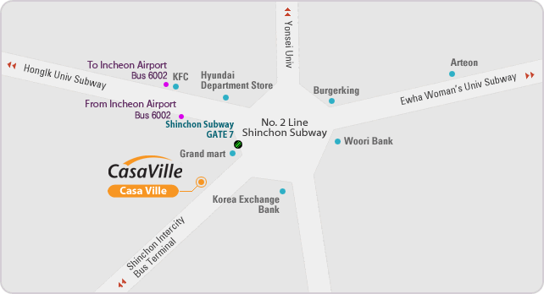
▶ To Ewha Womans Univ.
Subway: Take Subway line No.2 (Green line) at Sinchon station and get off at the Ewha Womans University station. Please be aware of the direction of the subway. (1 stop away, fare: 1,050 won)
Taxi fare: Approx. 3,000~4,000 won

3. Seokyo Hotel

Please note that Hotel Seokyo will be temporarily shut down for renovation during our conference.

4. Hotel President

Junior Single (24.51㎡) 120,000 won
Standard Single (31.87㎡) 140,000 won
Standard Double (34.54㎡) 180,000 won
Standard Twin (34.54㎡) 190,00 won
Business Twin (34.54㎡) 220,000 won

http://www.hotelpresident.co.kr/

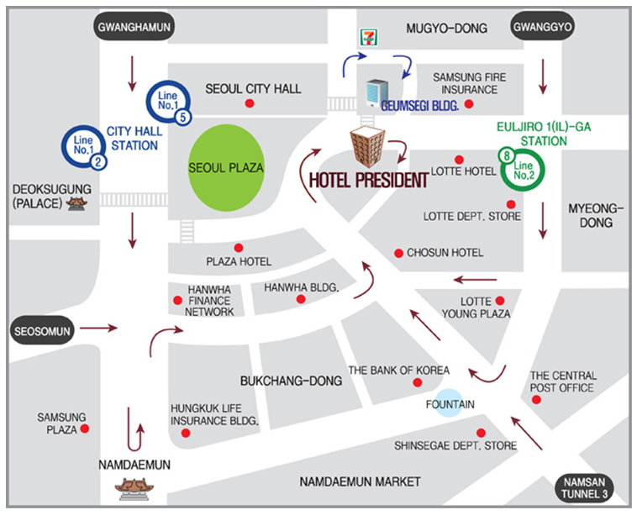

▶ To Ewha Womans Univ.
Subway: Take the subway line No.2 (Green line) at Euljiro 1-Ga station and get off at Ewha Womans University station. Please be aware of the direction of the subway. (4 stops away, fare: 1,050 won)
Taxi fare: Approx. 6,000 won
5. Co-op Residence
• SinChon Central Co-op residence http://rent.co-op.co.kr/rent_coop/eng/body10.htm
• Euljiro Co-op residence http://rent.co-op.co.kr/rent_coop/eng/body02.htm
• Western Co-op residence http://rent.co-op.co.kr/rent_coop/eng/body09.htm

6. Online Hotel Search and Reservation Services
http://www.koreahotel.com/kh_eng/main/main.php
Korea Hotel provides hotel information and reservation services for international travelers.
http://eng.hotelpass.com/main/default.asp
Hotel Pass provides hotel information reservation services for international travelers. It is staffed by about 60 operators who altogether assist 50,000 international visitors annually.
http://www.hotelscombined.com/PlaceLanding.aspx?destination=place%3aSouth_Korea&pageIndex=0&languageCode=EN
Hotels Combined offers a hotel price comparison service for 1,430 hotels in Korea. It offers real time booking availability and rates of over a 100 travel and hotel booking sites. The website is available in 39 languages.
http://www.agoda.com/country/south-korea.html?site_id=1452480
Agoda has a listing of more than 1,340 hotels and shares the reviews and experiences of over 78,000 travelers. VisitKorea members can earn Agoda Rewards points worth 4-7% of the room price and receive an extra 5% off on all listed Korean hotels. Make sure to log in to the VisitKorea website first. The discounted price will appear when you make a payment.
http://www.worldhotel.co.kr/main/
World Hotel offers information and assists with reservations for hotels, serviced residences, Korea tours, Seoul tours, DMZ tours, and ski tours. It has selected and listed only the top 300 hotels in Korea and offer 30-70% discounts. The Korea tour package program is operated by a group of professionals that conduct travel and guided tour programs for international visitors to Korea.
Source: http://english.visitkorea.or.kr/enu/RE/RE_EN_1_1_1_4.jsp

